Web Accessibility
and Use of Developer Tools
(Lighthouse Report)
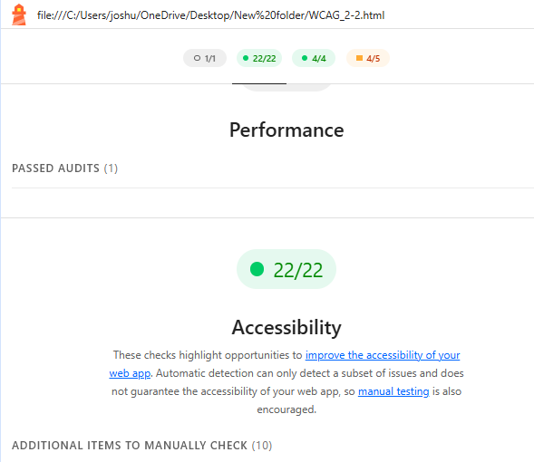

To the Reader:

I have successfully generated a Web Accessibility template that FULLY PASSED the Lighthouse Report for Web Accessibility, more specifically, WCAG 2.2.

